EU Declaration of Conformity

1. Product model:

MegaOil Model 15 / 16 Gloves and Mitten (Mega Oil-series 30cm, 40cm and 67cm)

2. Name and address of the manufacturer and where applicable, his authorised representative:

Center Plast AS
Straumøyveien 141
8056 Saltstraumen
Norway

3. This declaration of conformity is issued under the sole responsibility of the manufacturer.

4. Object of the declaration (identification of the product):

The glove/mitten has black colour hand, and Yellow cuff/sleeve, with-or without granulate in the grip.

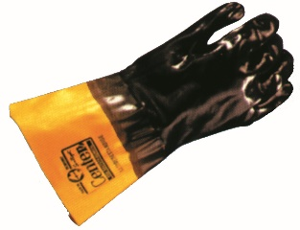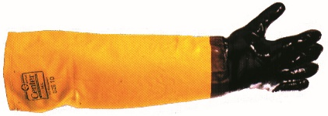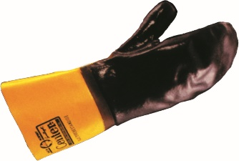

5. The object of the declaration described above is in conformity with the relevant Union harmonisation legislation: PPE Regulation (EU) 2016/425

6. References to the relevant harmonised standards used or references to the other technical specifications in relation to which conformity is declared:

EN 420, EN 374 and EN 388

7. The notified body SGS Fimko Ltd, 0598, Takomotie 8, FI-00380 Helsinki, performed the EU type-examination (Module B) and issued the EU type-examination certificate 0598/PPE/200144

8. PPE is subject to the conformity assessment procedure C2 under surveillance of the notified body SGS Fimko Ltd, 0598.
9. Signed for and on behalf of:

Saltstraumen 23.06.2020

Karsten Bjerkvik
General manager

